Data Quality & Documentation

Project: Predictive Maintenance – Equipment Failure Prediction Pipeline
Dataset: NASA CMAPSS Turbofan Engine Dataset
Domain: Manufacturing / Aerospace
Data Type: Time-series sensor data

DEFINE DATA QUALITY STRATEGY:
A data quality strategy is a structured approach to ensure that data is accurate, complete, consistent, timely, and reliable across all pipeline layers (Bronze, Silver, ML, Predictions) so that analytics and machine learning outputs are trustworthy and decision-ready.
Goal:
Ensure sensor, feature, and prediction data are:
- Complete
- Accurate
- Consistent
- Traceable end-to-end
Strategy Table:
Layer | Quality Focus
Bronze | Raw data integrity
Silver | Feature correctness
ML Input | No leakage / nulls
Predictions | Valid probability & labels

Validation Rules Definition:
Validation rules are predefined checks applied at each stage of the data pipeline to ensure data correctness, consistency, and reliability before it is used for analytics or ML.

Bronze Layer (Raw Sensor Data):
Purpose: Ensure ingested data matches source quality.
Rule | Validation
engine_id | NOT NULL
cycle | ≥ 1
sensor values | Numeric
row count | > 0
schema | Matches CMAPSS format

Validating Null Values:
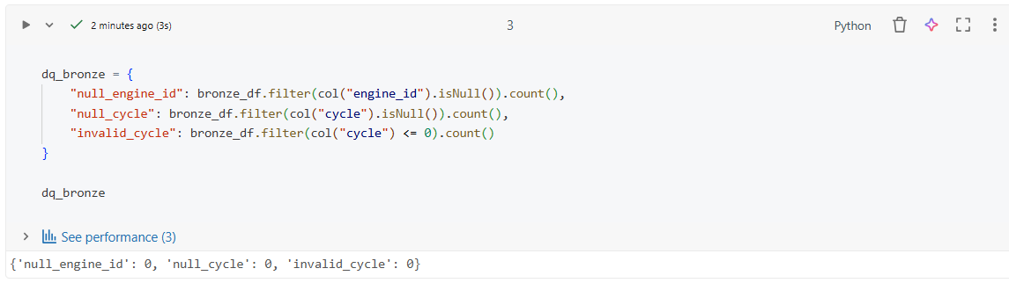
Row Count Check:
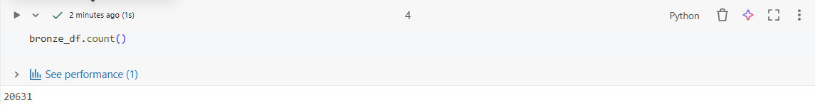
Status Logic:
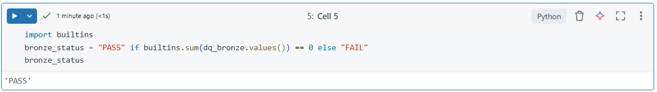
Silver Feature Validation:
Purpose: Ensure feature correctness.

Silver Validation Table:
Rule | Validation
Rolling features | NOT NULL
Delta features | Numeric
Cycle continuity | No gaps per engine
Feature range | No abnormal spikes

Outcome:
- Features correctly derived from Bronze data

Null Feature Check:
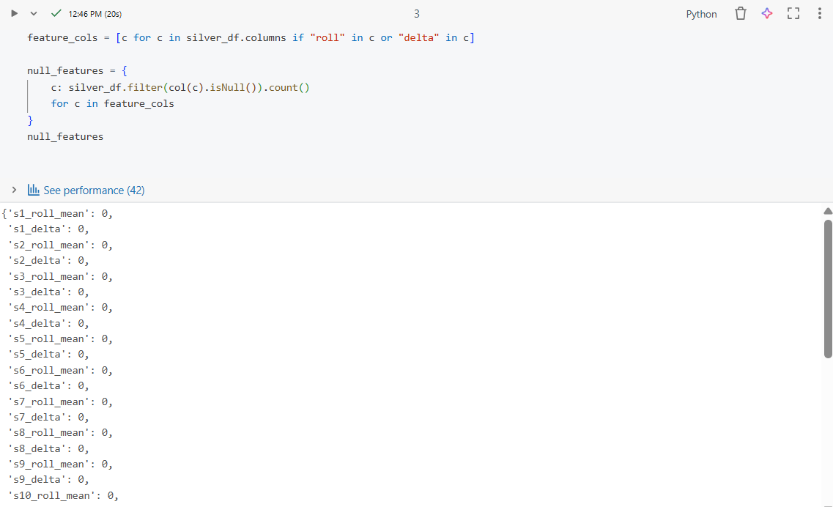
Cycle Consistency:
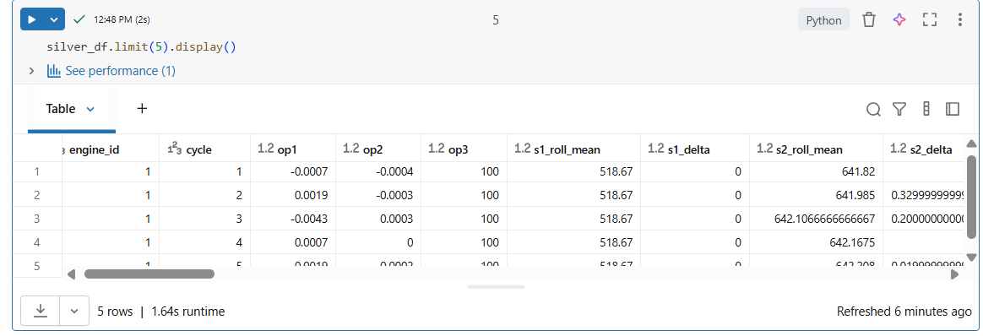

Label Validation:
Label validation ensures that the failure labels used for ML training are correct, consistent, and logically aligned with the Remaining Useful Life (RUL) definition. To verify that the generated failure labels correctly represent imminent engine failure based on RUL thresholds.
Label Validation Rules:
Check | Result
Label values | Only 0 or 1
Threshold applied | RUL ≤ 30
Temporal correctness | No future leakage
Outcome:
- Failure labels logically aligned with engine degradation

Validate Labels:
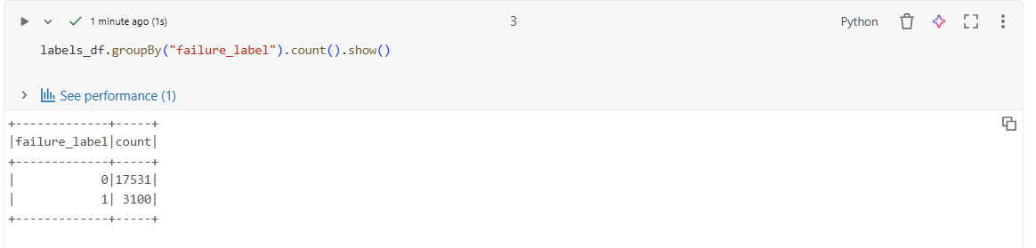
Threshold Check:
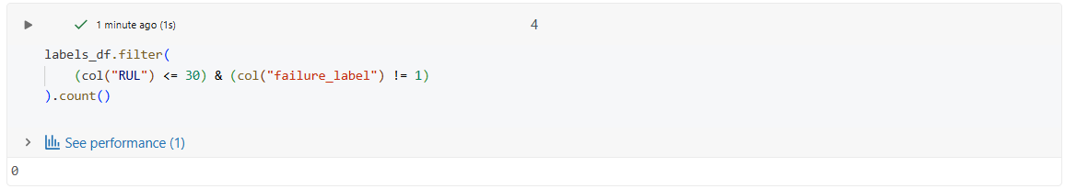

ML Input Validation:
ML Input Validation ensures that the dataset fed into the machine learning model is clean, consistent, complete, and aligned with what the model was trained on.

ML Dataset Rules:
Rule |  | Validation
Features vector | No NULL
Label | Binary (0 / 1)
Train/Test split | Engine-level separation
Class distribution | Acceptable imbalance
Model Input Summary
- Model: Spark ML (Logistic Regression)
- Input: Silver features + failure label
- Output: Probability & prediction
Outcome:
- ML inputs validated and safe for training
Class Distribution: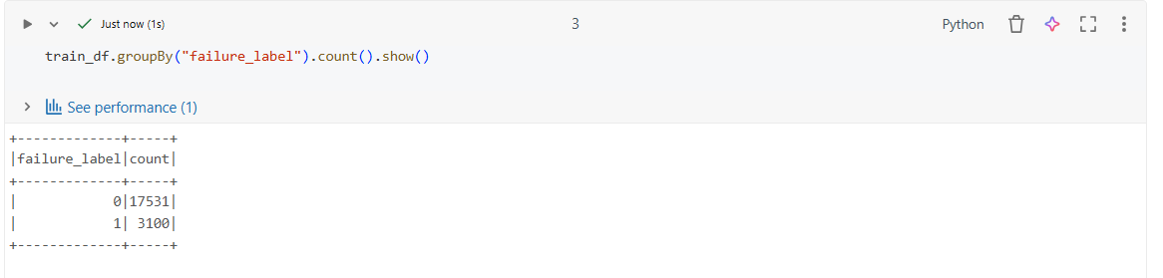
Prediction Output Validation:
Prediction Output Validation ensures that the machine learning model’s predictions are correct, interpretable, reliable, and usable for business decisions such as maintenance planning and risk monitoring.
Prediction Schema:
Column | Description
probability | Failure probability (0–1)
prediction | 0 = Safe, 1 = Risk
risk_level | LOW / MEDIUM / HIGH

Validation Rules:
Rule | Status
Probability range | 0 ≤ p ≤ 1
Prediction values | 0 and 1
Risk mapping | Correct

Probability Check:
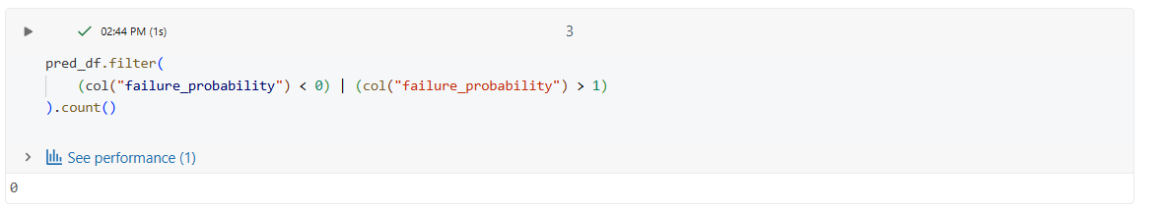
Risk Level Validation:
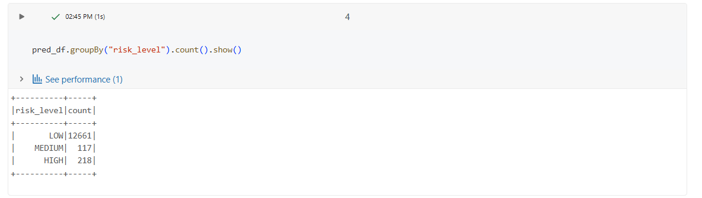

Audit & Control Table:
An Audit & Control Table is a centralized table used to track, monitor, and validate data processing activities across the entire pipeline (Bronze → Silver → ML → Predictions).
Purpose:
- Monitor pipeline health and job execution
- Track record counts and data quality checks
- Detect failures, anomalies, or data loss
- Support troubleshooting, compliance, and client audits

Table:
Column | Description
layer_name | Bronze / Silver / ML
record_count | 20637
validation_status | PASS
validation_date | 22/01/26

Business Value:
Provides end-to-end visibility and confidence that the predictive maintenance pipeline is producing reliable and auditable results.

